CHAPTER 1
INTRODUCTION

Introduction to AI-Powered Edge-Sign Language Translator

Computer vision, and embedded systems have enabled the development of intelligent assistive technologies that improve human–computer interaction. However, communication remains a significant challenge for individuals with speech and hearing impairments, particularly when interacting with people who are not familiar with sign language. This communication gap often limits their participation in everyday activities such as education, work, and social interaction.

Sign language is an effective mode of communication for such individuals, but its limited understanding among the general population creates a barrier. Existing solutions, such as human interpreters or text-based communication, are not always practical or available in real-time scenarios. Although several gesture recognition systems have been developed, many rely on high computational resources or function only in controlled environments, making them less suitable for real-world applications.

To address , this project proposes EdgeSign: An IoT-Enabled Edge–Cloud Hybrid System for Real-Time Sign Language Translation. The system captures hand gestures using a camera connected to a Raspberry Pi and extracts hand landmarks using the MediaPipe framework. These landmarks are processed using a machine learning model to recognize predefined gestures. The recognized data is then transmitted to the cloud, where advanced processing, including sentence generation and contextual enhancement, is performed. Finally, the output is converted into speech using a

The proposed system combines edge and cloud computing to achieve low latency and improved performance. Edge processing enables fast gesture detection, while cloud integration enhances accuracy and scalability. The system is aims to provide an accessible and reliable solution that bridges the communication gap and supports inclusive interaction for individuals with speech and hearing impairments.

Motivation
Although significant progress has been made in computer vision and machine learning, many gesture recognition systems are still limited in terms of real-world usability. Most existing approaches rely on high-end hardware, controlled environments, or continuous cloud connectivity, which makes them less practical for everyday use. These limitations highlight the need for a solution that is both efficient and deployable on low-cost, portable devices without compromising performance.
Another key challenge lies in achieving real-time response. Systems that depend entirely on cloud processing often introduce latency due to network delays, while fully edge-based systems may struggle with limited computational resources. This creates a trade-off between speed and accuracy that must be carefully balanced. Therefore, there is a strong motivation to design a hybrid system that combines the advantages of edge computing for fast data processing and cloud computing for advanced analysis and contextual understanding.
In addition, many existing systems focus only on recognizing individual gestures, without converting them into meaningful sentences or natural speech. This limits their effectiveness in real communication scenarios, where context and clarity are important. Integrating conversational AI and speech generation can significantly improve the usability and impact of such systems.
Furthermore, there is a growing need for assistive technologies that are affordable, scalable, and easy to use. By leveraging devices like Raspberry Pi and lightweight machine learning models, it becomes possible to develop a cost-effective solution that can be widely adopted. This motivates the development of the EdgeSign system, which aims to provide a practical, real-time, and intelligent communication aid by combining gesture recognition, edge–cloud processing, and speech synthesis in a single integrated framework.
Another motivating factor is the need for continuous improvement and adaptability in gesture recognition systems. Users may have variations in gesture style, speed, and hand orientation, which can affect system accuracy if not properly handled. Therefore, a system that can be easily updated with new data and improved models is essential for long-term usability.
The proposed EdgeSign system (SDG) 10: Reduced Inequalities, which focuses on promoting social, economic, and political inclusion for all individuals. Communication barriers faced by individuals with speech and hearing impairments often limit their participation in education, employment, and social interactions. By providing a real-time sign language translation system, this project aims to bridge this gap and enable more inclusive communication.
The system enhances accessibility by allowing users to convert sign language gestures into text and speech, making it easier for them to interact with people who are not familiar with sign language. This contributes to reducing inequalities by ensuring that differently-abled individuals have equal opportunities to express themselves and engage in daily activities. The use of affordable hardware such as Raspberry Pi also supports accessibility by making the solution cost-effective and scalable.
In addition, the project promotes digital inclusion by leveraging modern technologies such as edge computing, cloud integration, and artificial intelligence. These technologies help create an efficient and user-friendly assistive system that can be deployed in various environments, including schools, workplaces, and public spaces. Overall, the EdgeSign system contributes toward building a more inclusive society by empowering individuals with communication challenges and supporting the objectives of sustainable development.
Furthermore, the project also indirectly supports SDG 4: Quality Education by enabling better communication in learning environments for students with speech and hearing impairments. By providing a tool that translates sign language into understandable text and speech, the system helps create a more inclusive classroom setting where students can actively participate and interact with teachers and peers. This not only improves learning outcomes but also encourages equal educational opportunities. The integration of assistive technology in education further promotes awareness and acceptance, contributing to a more inclusive and equitable society.
Primary Audience:
- Individuals with speech or hearing impairments who require an intuitive, accessible, and real-time communication assistant to bridge the gap between sign language and spoken language.
Secondary Audience:
- Caregivers, teachers, therapists, and family members who support individuals with communication impairments and require effective tools to improve interaction with people.
- Inclusive organizations such as old Age-house,schools, hospitals, rehabilitation centers, and community service institutions that promote accessibility and assistive communication tech

Primary Needs:
- Real-time translator from sign language to spoken natural language by using a ML model.
- Accurate and low-latency gesture recognition using lightweight machine learning models.
Portable and cost-effective system that can be used in everyday environments.
Secondary Needs:
- Cloud integration for advanced processing and contextual sentence generation by API key
- Wireless audio output through speakers or headphones for seamless realtime communication.
- User-friendly interface for configuring gestures and monitoring system performance by Dev.

1.4.3 Products
Core Product:
- EdgeSign system: An edge–cloud hybrid sign language translation system using Raspberry Pi, MediaPipe for hand tracking, and machine learning models (Random Forest / ML model).
Additional Features:
- AI-based sentence generation using cloud integration (Gemini or similar) for generation.
- Text-to-Speech (TTS) module for real-time voice output (sentence generation it’s converted TTS).
- WebSocket-based communication enables efficient real-time data exchange between the edge device.
- Dataset logging and storage support continuous machine learning model improvement, performance.

1.4.4 Values
Core Values:
- Accessibility: Ensures communication is easy, inclusive, and available to everyone regardless of speech or hearing limitations.
- Efficiency: Delivers real-time system performance with minimal latency for smooth and responsive communication.
- Portability: enables the system to operate on compact, lightweight, and low-cost devices such as Raspberry Pi for everyday convenience.
- Scalability: Supports cloud integration for advanced processing capabilities, system enhancement, and future technological expansion.
- Usability: Provides a simple, intuitive, and user-friendly interaction experience suitable for daily use.
- Future Scope: Can be extended with improved models, larger datasets, and enhanced real-world deployment.
The EdgeSign to provide an accessible, efficient, and user-friendly communication solution for. It aims to bridge communication gaps by translating sign language gestures into meaningful text and speech in real time using a compact and portable edge device based on Raspberry Pi 4. The system leverages MediaPipe for accurate hand landmark detection and a machine learning model, such as Random Forest, for reliable gesture classification with low latency. By integrating edge–cloud architecture, the system ensures fast local processing while enabling advanced sentence generation and contextual understanding through cloud support. Additional features such as mobile application integration, wireless audio output, gesture customization, and real-time feedback enhance usability and adaptability in various environments. Designed with a focus on scalability, portability, and real-world deployment, the system can be effectively used in healthcare centers, educational institutions, workplaces, and home settings. Overall, EdgeSign promotes independent communication, improves accessibility, and supports inclusive interaction, making it a practical assistive technology solution for everyday use.

The EdgeSign system focuses on delivering a simple, reliable, and efficient communication experience for users by combining gesture recognition, text generation, and speech output into a unified platform. Its design emphasizes ease of use, portability, and real-time performance .

1.5 Product Goal

By offering a real-time sign language translation solution, the suggested system aims mostly to improve communication access. The system transforms hand signals into structured text and vocal output in order to allow easy and free communication in daily living. The system provides a straight, effective, and user-friendly communication route by lowering dependence on human interpreters and conventional means of communication.

Using the MediaPipe framework, which extracts hand markers in real time, gesture tracking is done. An algorithm based on machine learning, such as a Random Forest classifier, is used to precisely identify prearranged motions by means of these markers. The accepted gestures are next sent across an edge–cloud communication channel, where sophisticated processing produces pertinent and context-aware statements. This guarantees that the result is not confined to individual words but creates whole and natural sentences fit for actual interaction.

Furthermore included in the system are capabilities like gesture-to-text translation, text-to-speech (TTS) production, and cloud-based sentence enhancement. Speakers or Bluetooth-enabled devices supply audio output, which gives versatility in several application settings. Moreover, the system supports data logging and customisation options so that gesture recognition and adaptability can be constantly enhanced in line with user requirements.

Through the combination of edge and cloud computing, the project aims at low latency and high efficiency. While cloud processing improves accuracy and contextual understanding, edge processing helps quick gesture recognition and initial categorization. Making it ideal for use in public areas, healthcare facilities, and educational institutions, the system is meant to be scalable, affordable, and portable.

The objective of the product is ultimately to develop an intelligent assistive communication platform that encourages inclusivity, freedom, and accessibility. The system enables users to express themselves more clearly and engage boldly in everyday interactions by bridging sign language with spoken communication.

Product Backlog

The following table 1.1 represents the user stories in the form of a backlog table of the edge sign translation.

S.No | User Stories
#1 | As a user, I want the system to recognize my hand gestures accurately so that I can communicate effectively.
# 2 | As a user, I want my gestures to be converted into meaningful text so that I can form sentences.
3 | As a user, I want the system to generate speech output so that others can understand my message.
4 | As a user, I want the system to send gesture data to the cloud for improved processing and sentence generation.
5 | As a user, I want real-time response with minimal delay so that communication feels natural.
6 | As a user, I want to add custom gestures so that I can personalize communication.
7 | As a user, I want the system to ignore unknown gestures to avoid incorrect outputs.
8 | As a user, I want to see recognized words or sentences on a display or mobile interface.
9 | As a user, I want OCR-based text recognition so that I can capture and understand written text.
10 | As a user, I want to enable or disable the background noise filter for better audio output clarity.

The product outlines the key user that define the core functionalities of the EdgeSign system. These user stories capture the requirements for gesture recognition, text and speech conversion, cloud integration, and user interaction features. The backlog serves as a foundation for sprint planning and ensures that development remains focused on delivering an efficient, accessible, and user-centric communication solution.

The product backlog for the proposed EdgeSign: An IoT-Enabled Edge–Cloud Hybrid System for using Agile principles and is visually represented in Figure 1.1. It outlines all the key user stories that define the system’s intended functionality and implementation.
Each user story is designed from a specific user perspective and includes:
- MoSCoW prioritization to highlight the importance of each feature (Must Have, Should Have, etc.)
- Functional requirements such as gesture recognition, gesture-to-text conversion, speech output (TTS), cloud integration, and custom gesture mapping
- Non-functional requirements covering aspects like real-time response, low latency, system reliability, and efficient edge device performance
- Effort estimation and status tracking to support sprint planning, monitoring, and execution
This structured backlog ensures that development remains focused on building a user-centric, accessible, and efficient assistive communication system. It particularly aims to support individuals with speech and hearing impairments by providing a real-time, intelligent, and portable communication solution.

Figure 1.1 represents the MS planner board that has our functional implementation where all the tasks were completed simultaneously once it was done and reported to the guide.
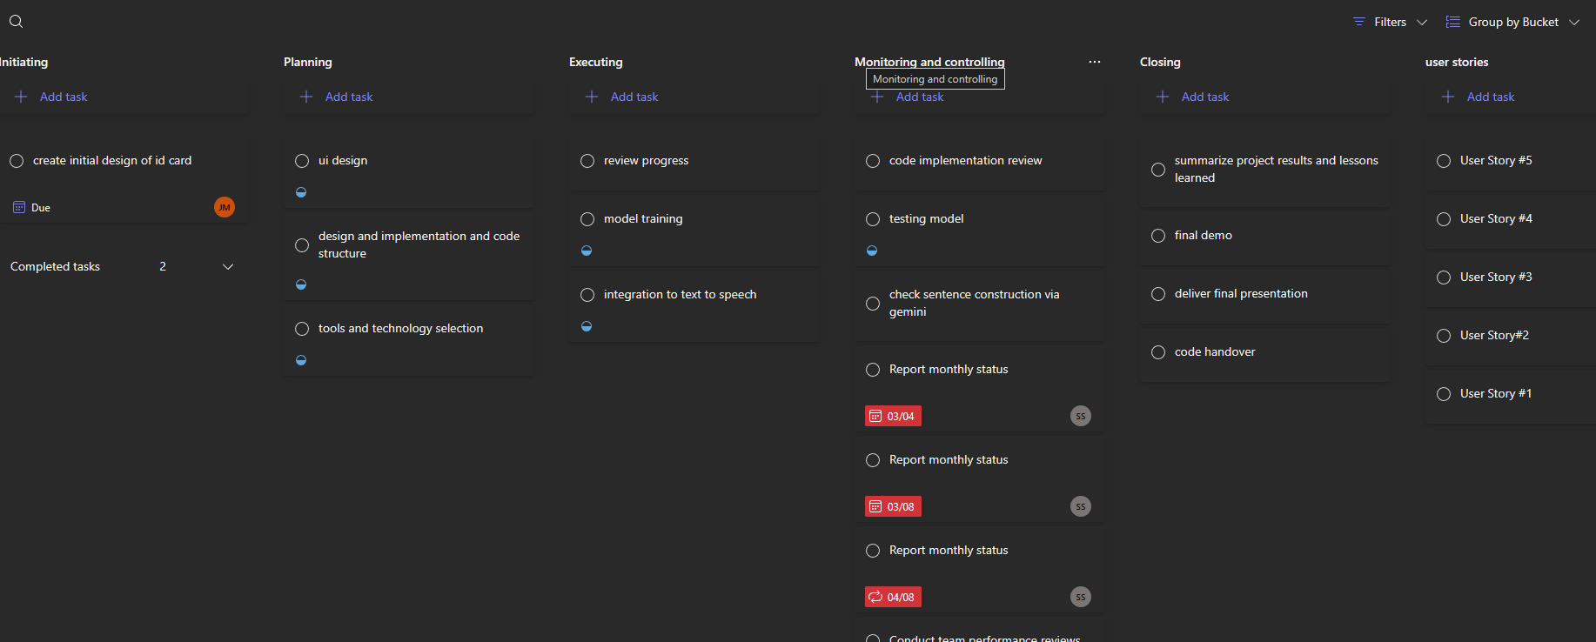

project where the project development was completely planned and executed

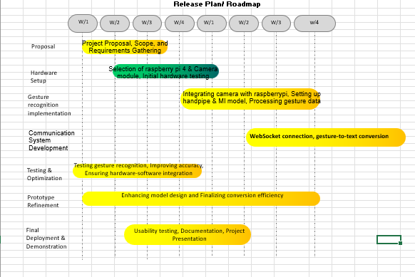

The product release plan illustrated in Figure 1.2 presents a structured roadmap for the development of the EdgeSign system, organized across multiple phases and weekly milestones. The process begins with the proposal phase, where project scope, objectives, and requirements are clearly defined to establish a strong foundation. This is followed by the hardware setup phase, which includes the selection and initial testing of essential components such as the Raspberry Pi 4 and camera module. In the gesture recognition implementation phase, the system is developed to capture hand gestures, extract features using MediaPipe, and process gesture data through a trained machine learning model. The communication system development phase focuses on integrating WebSocket-based communication and implementing gesture-to-text conversion to enable real-time data transmission and interaction.

Gesture Recognition System Setup

is to set up the project environment and implement the core gesture recognition module on the Raspberry Pi edge device. This includes capturing hand gestures using the Pi Camera, extracting hand landmarks using MediaPipe, and performing initial gesture classification using a machine learning model. The sprint focuses on establishing a functional pipeline for real-time gesture detection and basic communication.

The following table 2.1 represents the detailed user stories of the sprint 1 where gesture recognition system setup done.

S. No | Detailed
US #1 | the system to detect and identify my sign language gestures in real time so that I can communicate instantly and naturally. The system captures hand movements through the Raspberry Pi camera and processes them locally using MediaPipe and a trained Random Forest model to recognize predefined gestures with minimal latency.
US #2 | want to set up the Raspberry Pi environment with camera integration so that real-time gesture capture can be performed reliably. This includes configuring the Pi Camera, installing required libraries, and ensuring smooth data acquisition.
US #3 | extract and process hand landmarks using MediaPipe so that meaningful features can be provided to the gesture recognition model for accurate classification.

of user stories are mentioned below figures 2.1 which depicts the user story in the MS planner along with its priority and detailed information about it.
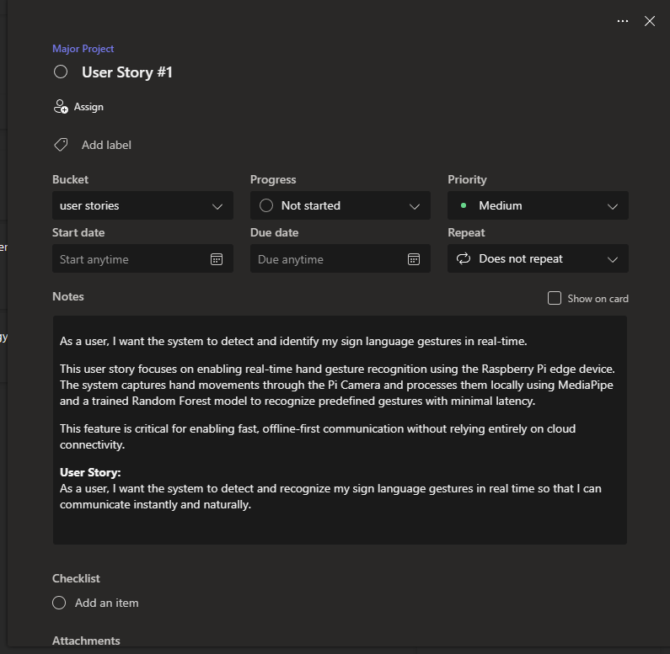

EdgeSign system is designed to provide an assistive communication solution for individuals with . The system enables real-time translation of hand gestures into text and speech using a combination of computer vision and machine learning techniques. In Sprint 1, the focus is on implementing the core gesture recognition pipeline on the Raspberry Pi edge device. This includes capturing hand gestures using the Pi Camera, extracting hand landmarks using MediaPipe, and classifying gestures using a trained machine learning model.
2.1.2.2 Product Goal

Achieving \ and basic text translation for a set of defined gestures is the main objective of this sprint. This underpins a more general assistive communication system, hence satisfying the aim of the project of providing available and inclusive conversational tools. The objective is to create a dependable edge-based processing pipeline running smoothly on the Raspberry Pi with little latency.

Though primarily for persons with speech and hearing impairments, The EdgeSign system also benefits carers and teachers helping them. For communication, these people depend on sign language and need assisting devices to engage more successfully in daily life. Originally designed and tested in confined settings, the system aims to expand its utility to actual uses like schools, healthcare facilities, and public spaces.

Several main mechanism propel the system. Real-time processing via the MediaPipe platform, which extracts hand landmarks, is done with a camera setup. By means of a machine learning model like a Random Forest classifier, which links these markers to established gesture categories, gesture categorization is accomplished. The acknowledged motions are subsequently translated into textual output, which forms the basis for more processing in following steps. This method guarantees correct and quick recognition with little computational load on the edge device.

2.1.2.3 Authorization Matrix

The following table 2.2 represents the Authorization Matrix, User Level of the Product

ROLE | ACCESS LEVELS
END USER | Uses the text or audio output in real time.
MOBILE PHONE USERS | Views recognized text, manages gesture mappings, and monitors system activity.
ADMIN | Adds or edits gesture datasets, manages model updates, and monitors system performance.

      - Features
Feature 1 – Edge–Cloud Gesture Processing
- Description

] hand gestures in real time through the Raspberry Pi camera, utilizes the MediaPipe framework to accurately detect and extract hand landmarks, processes gesture data locally on the edge device for low-latency response, and securely transmits the processed information to the cloud using WebSocket communication for advanced contextual analysis, refined sentence generation, improved recognition accuracy, and scalable performance enhancement. This edge–cloud hybrid architecture ensures efficient resource utilization while balancing speed, portability, and intelligent processing capabilities for assistive communication.
- User Story

As a user, I want my hand gestures to be captured, processed, and transmitted efficiently through edge–cloud communication so that the system can recognize gestures accurately and deliver real-time results.

2.1.2.5 Assumptions

• Raspberry Pi 4, camera module, and required hardware components will be available and functional throughout the sprint.
• The MediaPipe framework will accurately extract hand landmarks under normal lighting conditions.
• The machine learning model (Random Forest) will provide reliable gesture classification for predefined gestures.
• Stable communication between the Raspberry Pi and cloud services will be available for data transmission.
• Team members have sufficient knowledge of Python, machine learning, and embedded systems for development.
• The system will operate with acceptable latency for real-time gesture recognition and output generation.

The system assumes that the Raspberry Pi 4, camera module, and all required hardware components are available and function reliably throughout the sprint. It is expected that the MediaPipe framework can accurately extract hand landmarks under normal lighting conditions and that the Random Forest model will provide consistent gesture classification for predefined inputs. Stable communication between the Raspberry Pi and cloud services is assumed for seamless data transmission. Additionally, the development team is expected to have sufficient expertise in Python, machine learning, and embedded systems. The system is also assumed to operate with acceptable latency to support real-time gesture recognition and output generation.

Several main mechanism propel the system. Real-time processing via the MediaPipe platform, which extracts hand landmarks, is done with a camera setup. By means of a machine learning model like a Random Forest classifier, which links these markers to established gesture categories, gesture categorization is accomplished. The acknowledged motions are subsequently translated into textual output, which forms the basis for more processing in following steps. This method guarantees correct and quick recognition with little computational load on the edge device.

      - Application
Microservices:

We selected Microservices Architecture for EdgeSign cloud hybrid sign language translation System because of the following reasons:
- Scalability:
Microservices allow individual services such as gesture recognition, cloud processing, and text-to-speech to be scaled independently based on workload demands, ensuring efficient resource usage in the EdgeSign system.
- Flexibility:
Each service can be modified or upgraded without impacting other components, enabling easy feature additions such as new gesture models or enhanced cloud intelligence.
- Technology-Diversity:
Different technologies and frameworks can be used for different services (e.g., Python for edge processing, cloud APIs for AI inference), allowing the system to leverage the most suitable tools for each task.
- Faster Development and Deployment:
Independent development of services enables parallel work by team members, reducing development time and allowing faster testing and deployment cycles.
- Improved Maintainability:
Isolated services simplify debugging, testing, and maintenance,

      - Detailed Diagrams

Use Case Diagram

• User-performed sign language gestures initiate and trigger the communication system for real-time processing.
• The Text-to-Speech (TTS) module generates clear, natural, and understandable audio output for effective real-time communication.
• The gesture recognition module developed in Sprint 1 provides accurate and dependable input for sentence formation and translation
• Cloud services remain available, responsive, and efficient for advanced sentence generation, Figure 2.2 The use case diagram illustrates the interaction between the user and the EdgeSign system for real-time gesture-based communication. It shows how hand gestures are captured, processed, and converted into text and speech outputs through edge and cloud components. The diagram also highlights system features such as mobile app integration, audio output, and user-controlled settings.

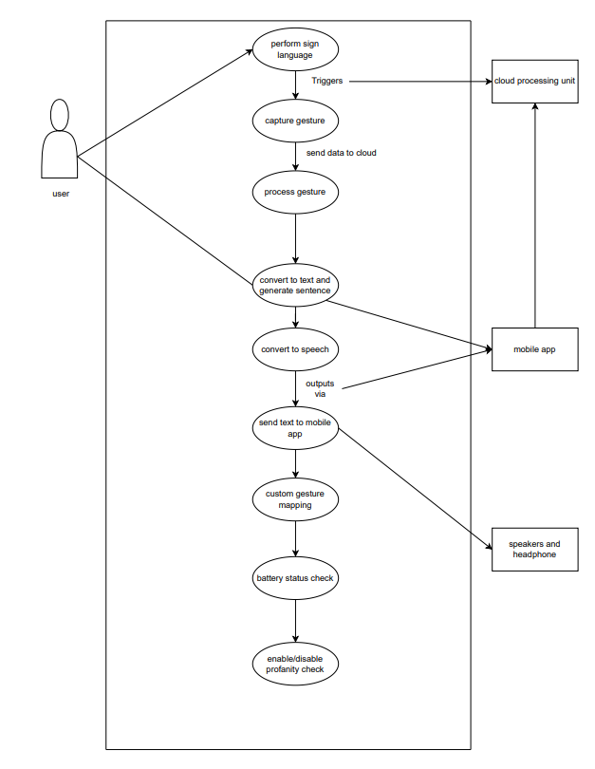
Figure 2.2 Use case diagram of edge sign translation

2.1.4

Figure 2.3 and 2.4 illustrates the ui design of the respective home page and hand detection

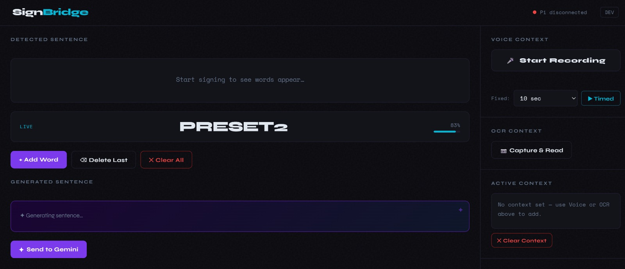

Fig 2.3
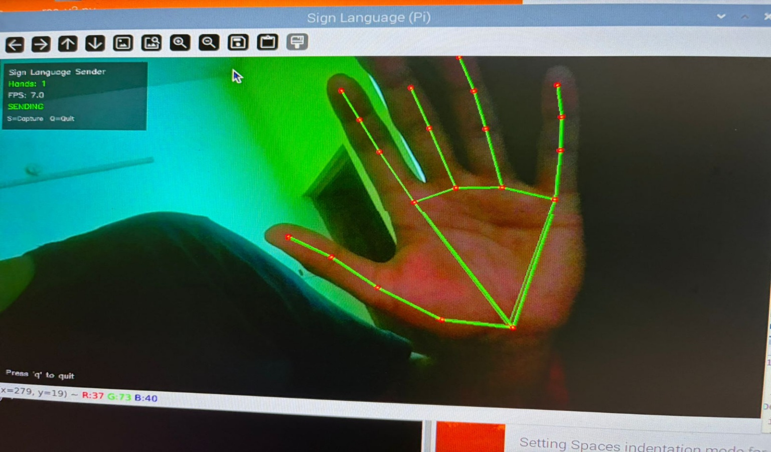

Fig 2.4 Hand Tracking And Landmark Detection

2.1.5

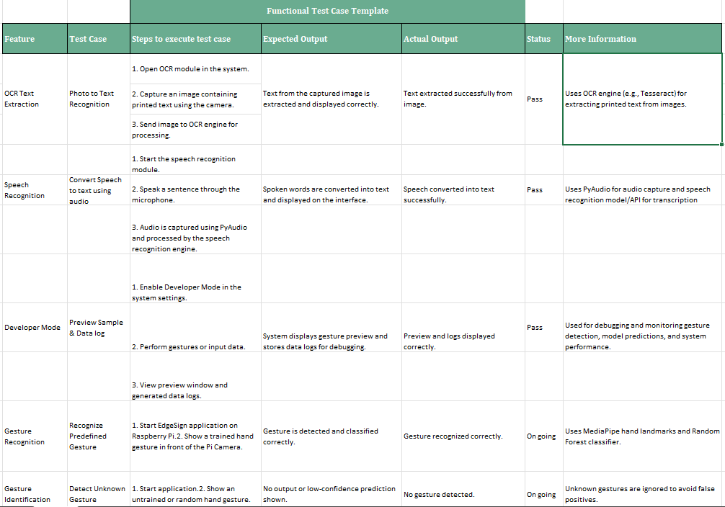

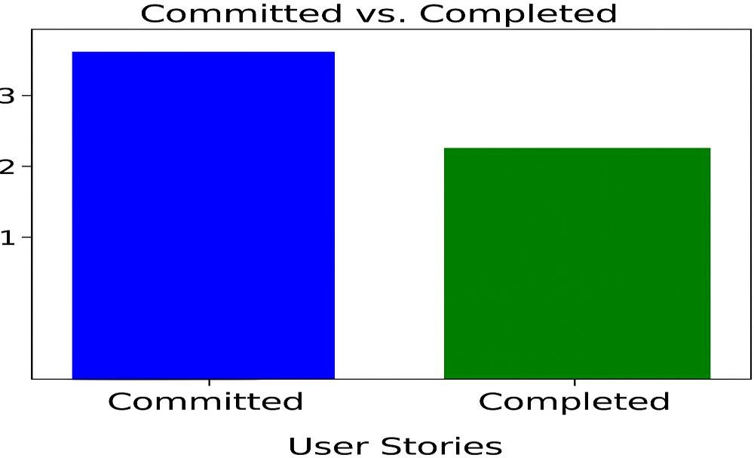
The following figure 2.5 represents the committed Vs Completed User Stories of sprint 1

2.1.7

Sprint 1 focused on establishing the foundational environment for the EdgeSign system and implementing the core gesture recognition module on the Raspberry Pi. The team began by setting up the hardware components, including the Raspberry Pi 4, Pi Camera, and a portable power setup. The software environment was configured using Python, OpenCV, and MediaPipe. The MediaPipe Hands module was utilized for real-time hand landmark extraction, which enabled accurate detection of hand gestures under normal lighting conditions. A machine learning model (Random Forest) was used to classify predefined gestures, forming the base of the recognition pipeline. Version control using Git was also established to manage development and track progress efficiently.

However, several challenges were encountered during the sprint. Gesture recognition accuracy was affected under low-light conditions, and minor frame processing delays were observed during continuous gesture input. Additionally, the initial dataset required refinement to improve classification consistency. These issues highlighted the importance of proper dataset preparation and environmental considerations. The team also recognized the need for modular testing, separating gesture detection and classification components to simplify debugging and improve system reliability.

Despite these challenges, Sprint 1 successfully delivered a working prototype capable of real-time gesture recognition. The sprint provided valuable insights into system limitations, particularly regarding lighting sensitivity and dataset diversity. It also emphasized the need for optimizing performance on edge devices.

Moving forward, the next sprint will focus on integrating cloud communication, implementing gesture-to-text sentence generation, and adding text-to-speech (TTS) functionality. Additional improvements will include expanding the dataset, optimizing model performance, and enabling interaction with a mobile application. Overall, Sprint 1 laid a strong foundation for building a scalable and efficient assistive communication system.

SPRINT 2 Communication & Output Integration

The goal of Sprint 2 is to extend the system by enabling gesture-to-sentence formation, integrating text-to-speech (TTS) for audio output, and establishing communication with the mobile application. This sprint focuses on improving user interaction by providing both visual and audio outputs, along with cloud-based processing for enhanced functionality.

S. No
US #4 | As a user, I want the device to play the translated text through a speaker so that I can communicate verbally with others. The system converts recognized text into speech using a TTS module and outputs it through speakers or Bluetooth audio devices.
US #5 | A\word or sentence to be displayed on the mobile UI so that I can visually confirm and track my communication. The system sends text data from the Raspberry Pi to the mobile application using WebSocket or BLE communication.
US #6 | = system to generate meaningful sentences from recognized gestures so that communication becomes more natural and context-aware.

where the respective user story is shared in the MS planner along with its priority and detailed information is shared.

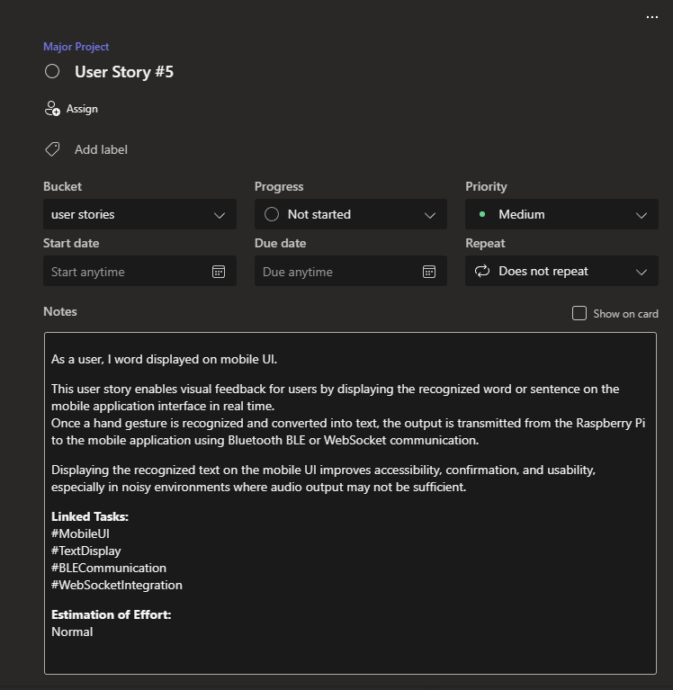

in camera

2.2.2.1 Introduction

Gesture-to-Speech and UI Integration Description
Once a gesture is recognized and classified into a word or phrase, the system converts it into speech using a Text-to-Speech (TTS) engine. The generated audio is played through speakers or wireless audio devices such as Bluetooth headphones. At the same time, the recognized text is transmitted from the Raspberry Pi to the mobile application using WebSocket or BLE communication, where it is displayed in real time.

2.1.2.2 Features
Feature 1 – AI-Based Sentence Generation
- Description:
Recognized gestures are converted into words and combined into meaningful sentences. Cloud based AI processing enhances sentence structure and context.
Story:
system to convert gestures into meaningful sentences that becomes natural and understandable.

2.2.2.3 Assumptions
• Stable WebSocket or BLE communication ensures reliable and seamless connectivity between the Raspberry Pi edge device and the mobile application.
• The module generates clear, natural, and understandable audio output for effective real-time communication.
• The gesture recognition module developed in Sprint 1 provides accurate and dependable input for sentence formation and translation.
• Cloud services remain available, responsive, and efficient for advanced sentence generation, contextual processing, and data handling.
• The mobile application is fully compatible and capable of displaying real-time text updates for smooth user interaction and monitoring

- Raspberry Pi 4 acts as the central edge device, capturing gestures and coordinating communication between components.
- Gesture Recognition Module (MediaPipe + ML Model) processes hand gestures by extracting hand landmarks using MediaPipe and classifying them using a trained Random Forest model. The Pi Camera captures real-time hand movements.
- Cloud Processing Unit receives gesture data from the Raspberry Pi via WebSocket communication and performs advanced processing such as sentence generation and contextual enhancement.
- Audio Output Module (Speaker / Bluetooth Audio) converts the generated text into speech using a Text-to-Speech (TTS) engine and plays it through speakers or Bluetooth-enabled devices.
- Communication Module (WebSocket / BLE) enables data transfer between the Raspberry Pi and the mobile application for real-time text display and system interaction.
- Mobile Application displays recognized text, allows custom gesture mapping, and provides controls such as enabling or disabling features like profanity filtering.
- Data Storage Module stores gesture datasets, mappings, and logs for improving system performance and training.
- Power/Battery Module supplies power to the Raspberry Pi and monitors battery levels to ensure uninterrupted operation.
The architecture diagram illustrates the complete EdgeSign system workflow, where the Raspberry Pi 4 serves as the core edge device responsible for real-time gesture capture, hand landmark detection using MediaPipe, and local machine learning-based gesture recognition. By adopting an edge–cloud hybrid architecture, the system processes critical gesture inputs locally for low-latency performance while transmitting gesture data to the cloud through WebSocket communication for advanced contextual sentence generation, enhanced language processing, and improved accuracy. The cloud layer strengthens the system by refining gesture outputs into meaningful sentences and enabling scalable AI-powered enhancements. Finally, the processed output is delivered to users through a mobile application as real-time text updates and through audio devices using Text-to-Speech technology, ensuring seamless, accessible, and efficient communication for individuals with speech or hearing impairments across everyday environments.
Figure 2.7 depicts the system architecture \, local storage, and wireless audio output on a Raspberry Pi 4 to enable seamless communication for speech- and hearing-impaired users.

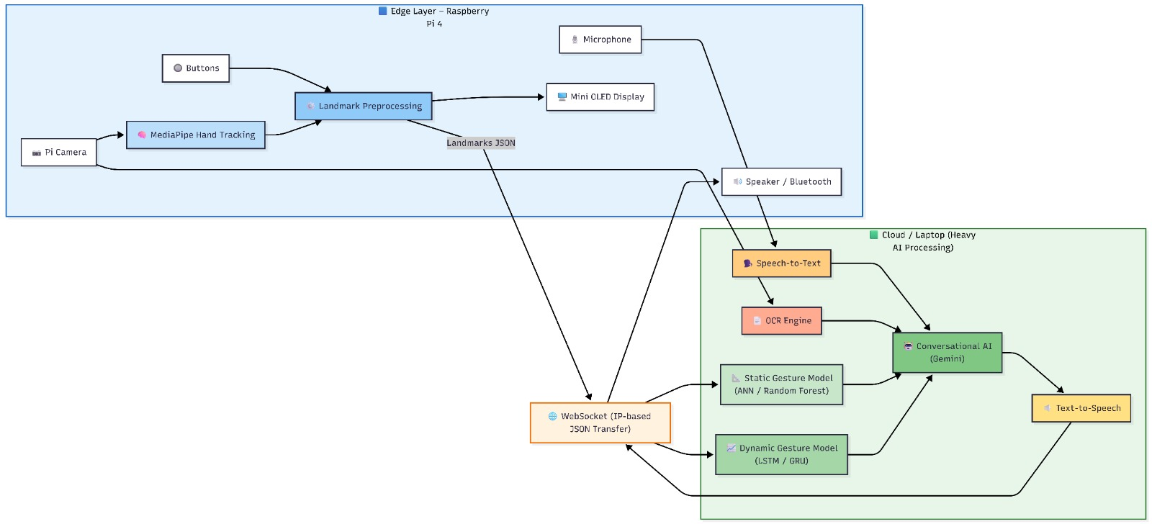

Figure 2.7 Architecture diagram of the edge cloud sign translation system

The system architecture follows a modular design Pi 4 acts as the central processing unit, handling gesture capture, preprocessing, and initial classification at the edge. The processed data is communicated to the cloud through WebSocket for advanced processing such as sentence generation and contextual enhancement. The architecture also integrates output modules, including web app UI and text-to-speech audio output, ensuring efficient, real-time, and user-friendly communication.

shows the Dev panel for remote debugging where the display board is connected
to the UI which shows the frame rate and ocr results along with the audio input details.

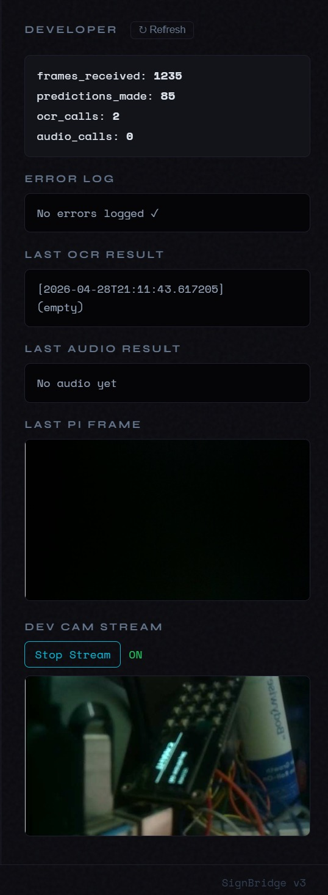
Fig 2.8 Dev panel for remote debugging

Feature | Test Case | Steps to execute test case | Expected Output | Actual Output | Status | More Information
OCR Text Extraction | Photo to Text Recognition | 1. Open OCR module in the system. | Text from the captured image is extracted and displayed correctly. | Text extracted successfully from image. | Pass | Uses OCR engine (e.g., Tesseract) for extracting printed text from images.
 |  | 2. Capture an image containing printed text using the camera.
 |  | 3. Send image to OCR engine for processing.
 |  | 1. Start the speech recognition module.
Speech Recognition | Convert Speech to text using audio | 2. Speak a sentence through the microphone. | Spoken words are converted into text and displayed on the interface. | Speech converted into text successfully. | Pass | Uses PyAudio for audio capture and speech recognition model/API for transcription
 |  | 3. Audio is captured using PyAudio and processed by the speech recognition engine.
Developer Mode | Preview Sample & Data log | 1. Enable Developer Mode in the system settings. | System displays gesture preview and stores data logs for debugging. | Preview and logs displayed correctly. | Pass | Used for debugging and monitoring gesture detection, model predictions and system performance
 |  | 2. Perform gestures or input data.

2.2.6

In The chart compares the number of user stories committed versus those successfully completed during the sprint execution

2.2

Sprint 2 focused on enhancing the prototype from a basic gesture recognition system to a more complete communication solution capable of generating sentences and delivering both visual and audio outputs. The primary goal was to design a system that could process sequences of recognized gestures and convert them into meaningful text, while also enabling real-time interaction through a mobile interface. The integration of WebSocket-based communication allowed seamless transmission of recognized text from the Raspberry Pi to the mobile application, where users could view and track the generated output.

In parallel, the team worked on integrating Text-to-Speech (TTS) functionality to convert the generated text into audio output. Once a gesture or sequence of gestures was recognized and processed, the system generated speech output, which was played through speakers or Bluetooth-enabled devices. This significantly improved the usability of the system by enabling users to communicate verbally without relying on external assistance.

Project Outcomes

Figure 3.1 The figure represents the user interface of the EdgeSign system, designed for real-time gesture-based communication. It displays detected words, generated sentences, and allows users to manage inputs through simple controls. The interface integrates features such as voice input, OCR capture, and AI-based sentence generation. Overall, it provides an interactive and user-friendly platform for seamless communication.


Figure 3.1 UI Front end

Figure 3.2 shows the display buttons of the led display along with in the UI web application

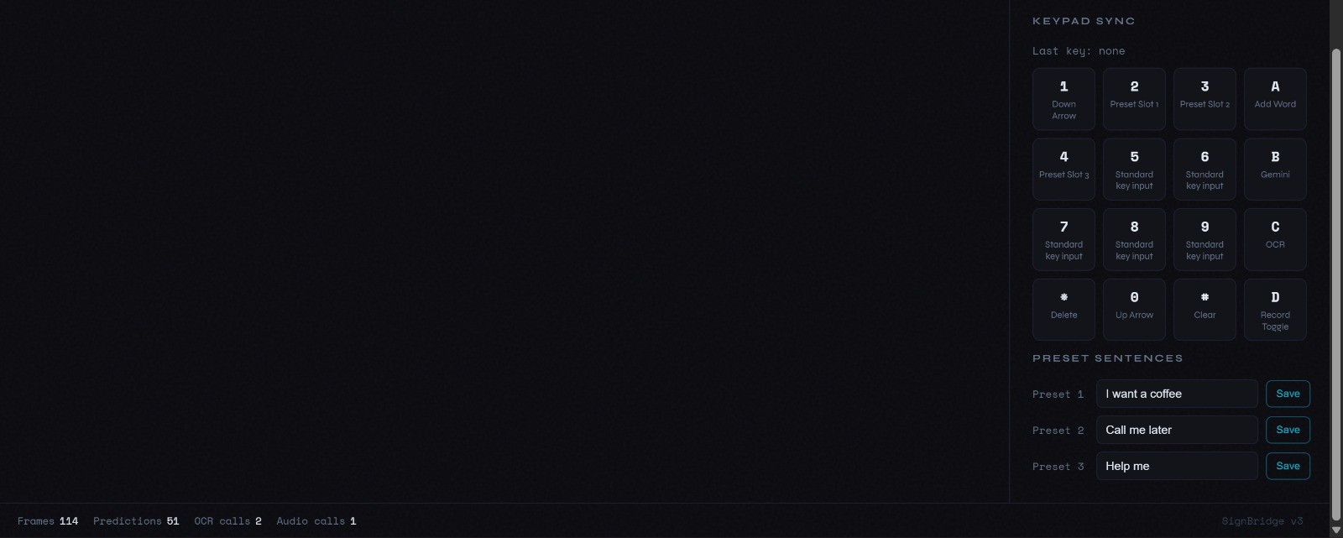
Figure 3.2 led display Integration
Figure 3.3 shows the hand recognition in the camera module where it tracks the finger movements and input landmarks are taken.
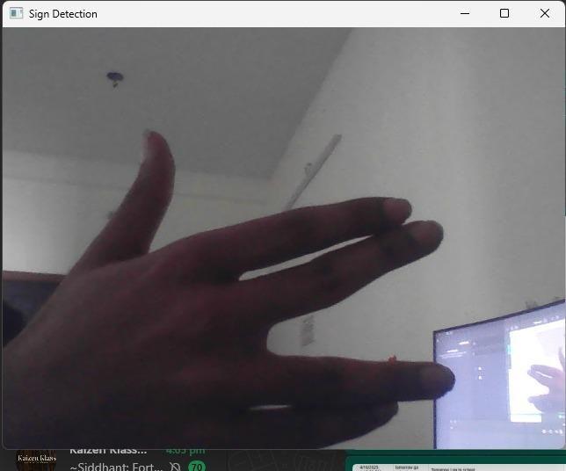
Figure 3.3 Hand gesture Recognition

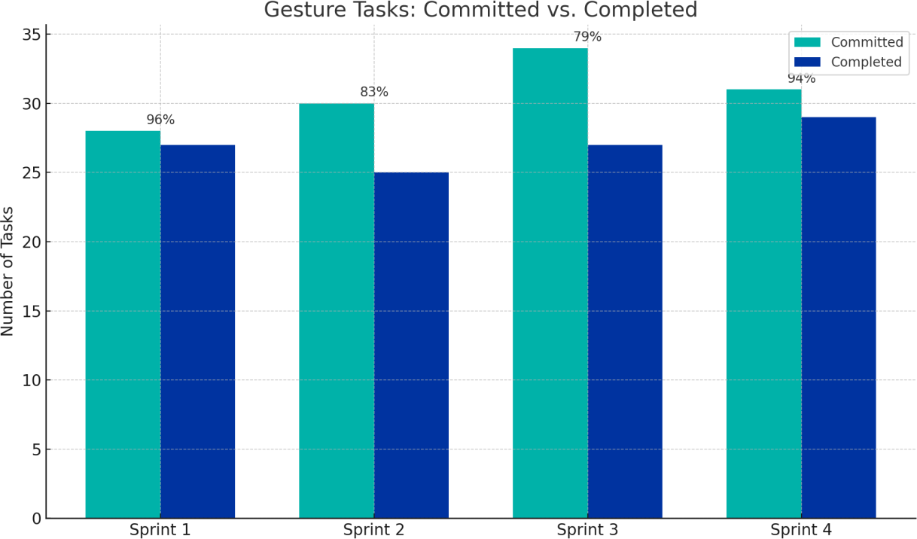
Fi

Figure 3.4 Committed vs Completed User Stories

The bar graph illustrates the comparison between committed and completed user stories across different sprints. It shows that Sprint 1 achieved a high completion rate, indicating effective initial planning and execution. In Sprint 2 and Sprint 3, a slight gap between committed and completed tasks can be observed due to increased system complexity and integration efforts. However, the completion rate remains consistently high across all sprints. Sprint 4 demonstrates improved task completion, reflecting better optimization and stability in the system. Overall, the graph highlights steady progress and effective sprint management throughout the project lifecycle.
The graph also indicates improved team coordination and task prioritization in later sprints.
The slight variations between committed and completed tasks highlight real-world development challenges. Continuous improvements throughout the sprints contributed to better efficiency and delivery outcomes. Overall, the results demonstrate a well-managed agile process with consistent performance.

CHAPTER 4
CONCLUSION & FUTURE ENHANCEMENTS

Conclusion

One major move toward better s is the creation of the EdgeSign, an IoT-Enabled Edge–Cloud hybrid system for real-time sign language translation. By expertly combining computer vision, embedded systems, and machine learning, this project creates a useful and real-time gesture recognition and communication system. Capturing hand motions via a camera, the system processes them via the MediaPipe framework for landmark extraction using Raspberry Pi 4 as the core edge device. For gesture categorization, a machine learning model like Random Forest is utilized to guarantee precise and effective recognition. Converting acknowledged gestures into significant text and creating spoken output using a) module helps the system to improve communication even further. Edge–cloud architecture helps to facilitate effective data processing since preliminary gesture recognition is done on the edge device and sophisticated processing such as sentence creation is managed in the cloud. WebSocket or BLE protocols enable real-time transfer of data to a mobile application for interaction and display, thus achieving component communication.
Future enhancement

Though the present system achieves its main goals, several improvements may enhance its performance, usability, and scalability even further. One great advancement is the inclusion of bespoke gesture training, which lets consumers to specify personal gestures and build the system's lexicon. Particularly in diverse backdrops and under different illumination, model accuracy can also be raised by enlarging the dataset size and variety. Future research can concentrate on improving natural language processing abilities by combining more sophisticated artificial intelligence models for better sentence generation and situational understanding. Supporting many languages and local dialects would greatly improve access and usability among several user groups. Furthermore lowering latency and enhancing system responsiveness can come from bettering interaction between edge and cloud elements. Hardware-wise, wearable technologies like smart gloves or sensors can be added to the system for better gesture accuracy and user comfort, therefore improving it. Real-time confirmation to users during gesture input can be provided via feedback systems including vibration or LED signals. On the programming front, cloud-based storage and analytics can support remote updates, ongoing system enhancement, and more efficient usage pattern monitoring.

